Year 10 Semester One - Paper A

Mathematics Examination
Part One: NO Calculators Allowed

Name ________________________________ Teacher _______________________

TIME ALLOWED FOR THIS PAPER
Reading time before commencing : 5 minutes.
Working time for paper : 50 minutes.

MATERIAL REQUIRED /RECOMMENDED FOR THIS PAPER

TO BE PROVIDED BY THE SUPERVISOR
This question paper comprising 5 questions.
Attempt ALL questions.
Total marks for the paper : 70
Answers are to be written on this test booklet in the spaces provided.

TO BE PROVIDED BY THE CANDIDATE
Pens, pencils, eraser.
One (1) A4 page of notes (handwritten, photocopied or typed on both sides) that may be either personally or commercially produced.

INSTRUCTIONS TO CANDIDATES
Write all answers in the spaces provided - if working is completed on extra pages, indicate on the original question that your working continues elsewhere.
If extra paper is needed in any section, please ask one of the supervisors.

Show all working clearly, in sufficient detail to allow your answers to be checked readily and for marks to be awarded for reasoning. No marks will be awarded to incorrect answers without supporting reasoning.

Question | Total possible marks | Your mark
1 | 20
2 | 18
3 | 14
4 | 14
5 | 4
Total | 70
Question 1 [20 marks]

a) Classify each number in the table below by placing a tick in the appropriate places.

 | –5 | 0 | 50% | 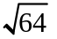 |  |  | 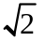
Positive integer
Negative integer
Rational number
Irrational number
[7]

b) (i) The mean radius of the earth is 6 371 000 m. Express this measurement using scientific notation.

(ii) The mean radius of the moon is 1.738 x 10⁶ metres. Write 1.738 x 10⁶ metres as a number without scientific notation.

(iii) The diameter of a single human hair is approximately 0.000 071 m. Express 0.000 071 in scientific notation.

(iv) A nanometre is 10⁻⁹ metres. Express this in decimal form.

[4]
c) Estimate the value of 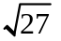. Show how you arrived at your answer.

[3]
d) Simplify the following to an expression that contains radicals of prime numbers.

(i) 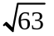 (ii) 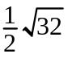

(iii) 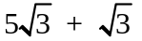 (iv) 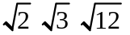

[6]
Question 2 [18 marks]

a) Evaluate the following.
(i) 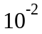 (ii) 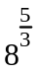 (iii) 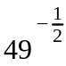

[6]
b) Simplify the following.
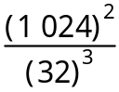

[4]
c) Simplify and express with positive indices.

(i) 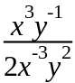 (ii) 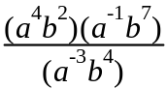

(iii) 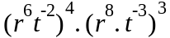 (iv) 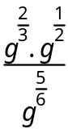

[8]
Question 3 [14 marks]

1. a) Solve the following by factorising:
(i) a² – 49 = 0 (ii) 3r² – 21r = 0

[4]

b) The length of a rectangular lot is 3 metres more than its width.
(i) Let the width be w. Draw a diagram and label the length and width in terms of w.

(ii) Find the length and width of the rectangular lot if the area is 40m².

[5]

c) Solve by equating to 0 and factorising.

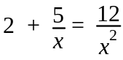

[5]
Question 4 [14 marks]

1. Complete the following table by matching each graph (A, B, C, D, E, F) with an equation below. Some graphs may not be matched.
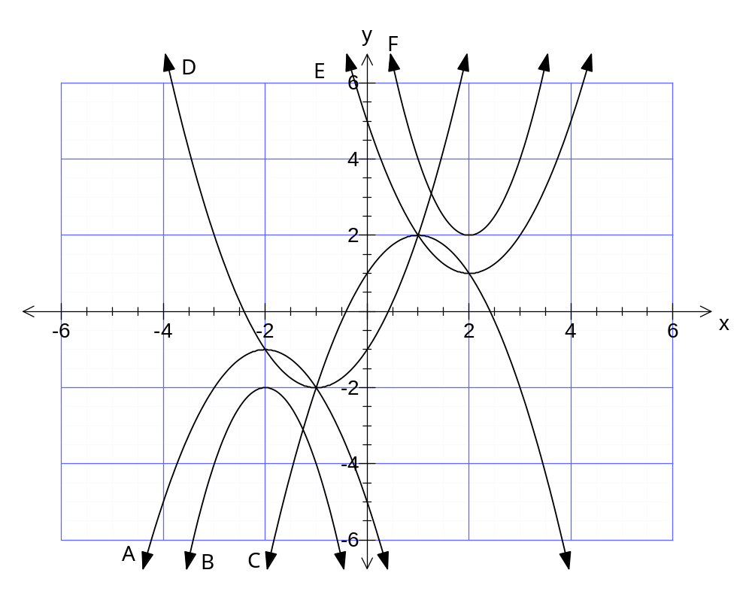

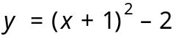 | 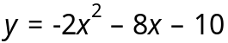 | 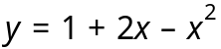 | 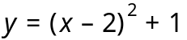

[4]
b) The graph of y = x² is translated 3 units to the right and 4 units down. What is the equation of the new parabola?

[2]

c) (i) The graph of y = 2x² is reflected about the x- axis, then translated 1 unit left and 5 units up. What is the equation of the new parabola?

[4]
(ii) What is the turning point, y intercept and equation of line of symmetry of the new curve?

[4]
Question 5 [4 marks]

The following figure contains a pair of congruent triangles.

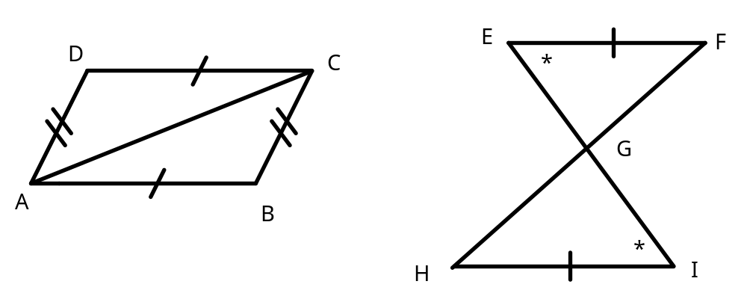

a) State the congruence (i.e. Δ??? Δ???)

[1]

b) State the condition for congruent triangles that applies.

[1]

c) Describe a transformation which maps one triangle onto the other.

[2]

